ETEC 326 Logbook – Dmytro Turynok

January 13th - Determine Drone’s Components:

After having a meeting in College with my team, we found out a list of components that are required for the drone to operate correctly. Following list of components are: Flight controller, Electrical Speed Controller (ESC), Antenna receiver, Frame, Battery, Video transmitter, FPV Camera.

A list of components with price, weight, and link for online order:

|  |  |  |  |  |  |  |
| --- | --- | --- | --- | --- | --- | --- |
| **Component** | **Weight (g)** | **Voltage (V)** | **Price** | **Quantity** | **Source** | **Important parameters** |
| Frame:  TBS Sourcecode V5 | 123.5 g | N/A | 47$ | 1 | <https://rotorvillage.ca/tbs-source-one-v5-5/> | 1. Stack mounting: 30.5mm x 30.5 mm;  2.  Motor dimensions  3. Little space at the bottom to extend servo motor wires. |
| Flight Controller +ESC: SpeedyBee F405 | 9.6g | 3S-6S | 50$ | 1 | <https://rotorvillage.ca/speedybee-f405-v3-30x30-flight-controller/> | 1. A datasheet with all required parameters  2. Has extra UART connections, potential use for servo motor (3.3V output) 3. SDA&SLCK  4. Same mounting as on the frame 5.COMING TOGETHER WITH ESC - SpeedyBee BLC 50A 4-in-1 ESC  6. Kit has extra parts for assembly (power cable, capacitor, DJI cable) |
| Motor:  T-Motor Velox V3 2550KV | 37.3gx4=150g | 6s | 81$ | 4 | <https://rotorvillage.ca/t-motor-velox-v3-2207-1750-1950-2550kv-motor/> | 1. Compatibility with battery (6s)  2. Idle current: 1.28A 3. Peak Current (1 min): 34.6A |
| Video Transmitter:  Happymodel OVX300 | 0.9g | 5V | 30$ | 1 | <https://rotorvillage.ca/happymodel-ovx300-25-300mw-5-8ghz-u-fl-vtx-w-openvtx/> | OPTIONAL ; |
| HAPPYMO.,; DEL EXPRESSLRS EP1 2.4GHZ RX | 0.5g (without antenna) | 5V | 20$ | 1 | <https://rotorvillage.ca/happymodel-expresslrs-ep1-2-4ghz-rx/> | Not from the video,  1. |

February 3rd – Found an stl file for soft robotic gripper:

A soft robotic grip is the novelty that will be added to the project. The claw will be printed out of TPU/TPE filament plastic, which is very light and easy to operate with.

First printing stage:

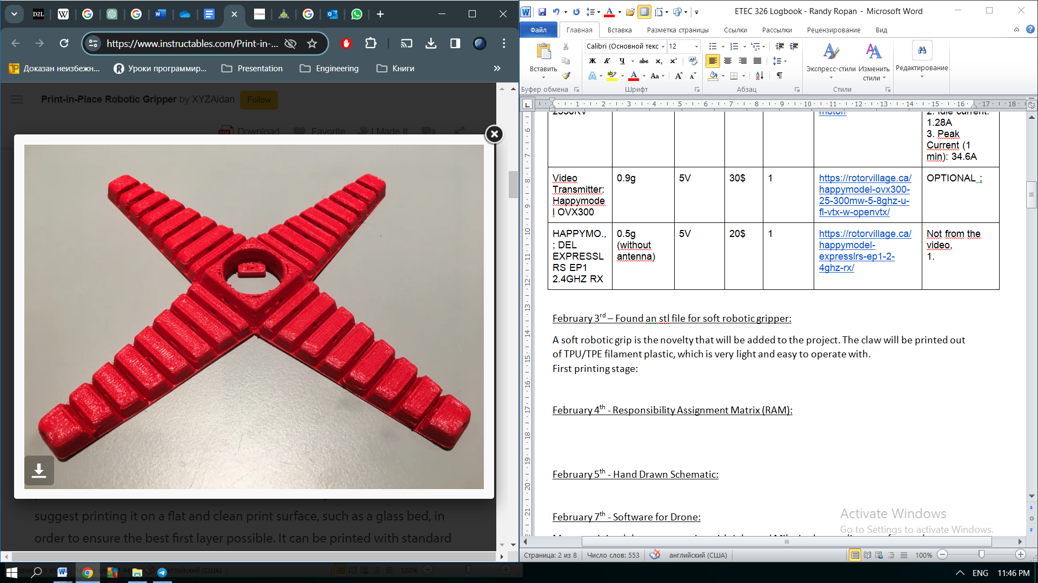

Adding a servo motor:

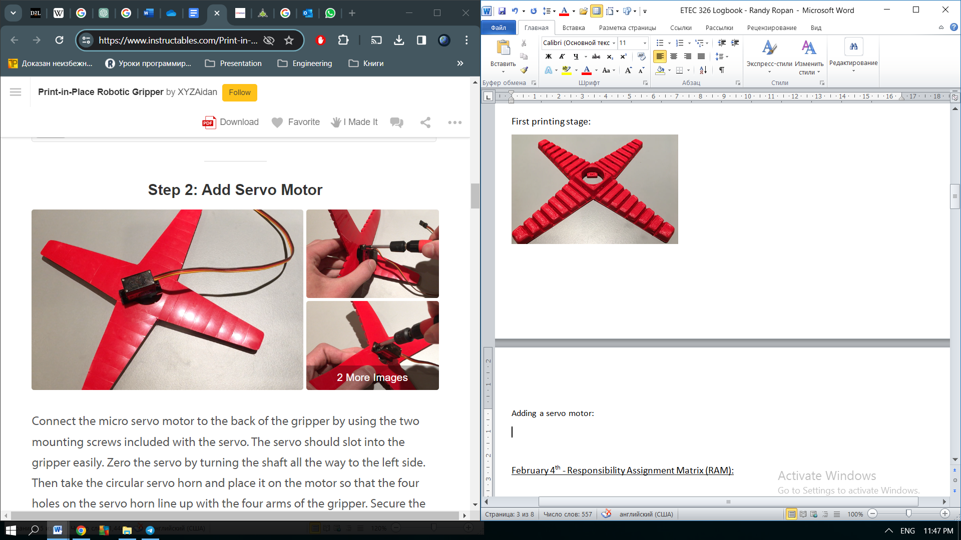

February 4th – Updated a Throttle and Thrust information:

In order to figure out the requirement for the payload, we need to know the amount of throttle that each motor can produce. Following information I found on the user manual under the motor:

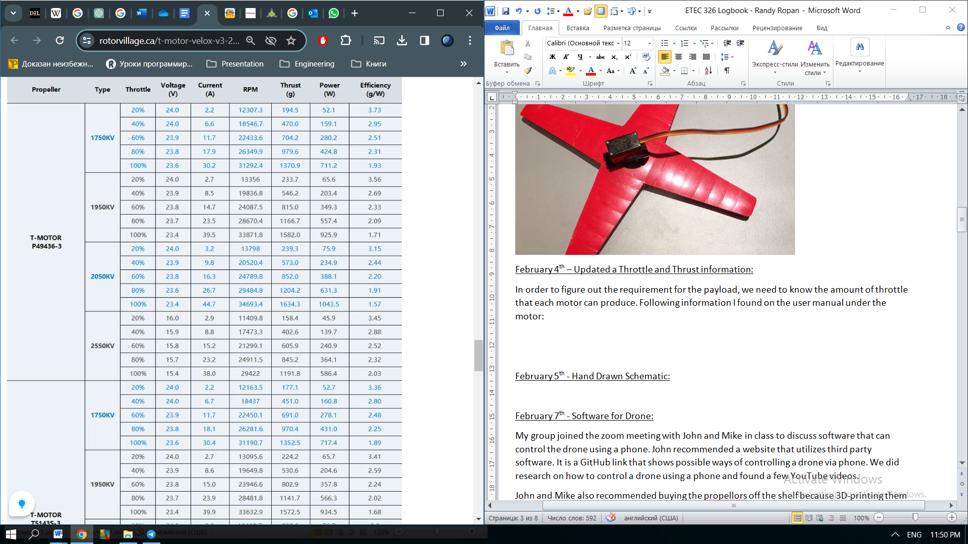

So, for 100% throttle out motor type 1950 KV, will be having a thrust of 1.5kg. Multiply it by 4 we will get 6 kg. However, with the weight of the drone the payload will be for sure about 2-3 kg.

February 5th – Updated the Hardware and Software diagram:

GPS

Optical flow sesor

Camera module

Telemetry

3D printed claws

Servo Motor

Bluetooth (Rx)

Payload system

Propellers

Motor

Electronic Speed Controller (ESC)

Driving unit

AV Receiver

RC Transceiver

Ground Control System (GCS)

Comm.unit

Flight Controller Board

Main Processor

Off-board module

Bluetooth (Tx)

Temperature sensor

Barometer

Magnetometer

* Gyroscope
* Accelerometer

Signal input/Protocol

RF

PWM

I2C

UART

Software Diagram (Dmytro):

Flight Control Software

“1”

“0”

If Input payload button = 1

Flight Algorithm (PID)

Payload Actuation signals

“0”

“10”

“01”

Drive motors

Release/ Grip

Motor sleep mode

3-axis claw release

“1”

3-axis claw grip

“01”

Activate motor

“00”

Up/Down

Turning left/right

“00”

“10”

“01”

“11”

Go down

Go up

Go left

Go right

**Flight Control Software**: This software module includes algorithms for stabilizing the drone during flight, such as PID (Proportional-Integral-Derivative) controllers.

**Payload Control Software**: This software module manages the control of the payload attached to the drone, such as a gripper. It may include logic for opening, closing, and manipulating the payload.

**Flight Algorithms**: These algorithms process sensor data (e.g., IMU, GPS) to determine the appropriate motor control signals needed to stabilize and maneuver the drone.

**Payload Control Algorithms**: These algorithms interpret commands received from the payload control software and generate control signals to actuate the payload mechanism accordingly.

**Motor Control Signals**: These signals, typically in the form of PWM (Pulse Width Modulation), are sent from the flight control software to the ESCs (Electronic Speed Controllers) to adjust the speed of the motors.

**Payload Actuation Signals**: These signals are generated by the payload control software and sent to actuators or control hardware to manipulate the payload mechanism.

**Motor Outputs**: These signals are received by the motor controllers (motor drivers), which then drive the motors accordingly.

**Payload Outputs**: These control signals are received by the payload controller (microcontroller), which then actuates the payload mechanism.

**Drone Hardware**: This encompasses all physical components of the drone, including motors, ESCs, and the flight controller.

**Payload Hardware**: This includes the mechanical and electrical components of the payload, such as actuators and sensors.

**Bluetooth Communication**: While not explicitly depicted in the diagram, Bluetooth communication between the drone and the remote controller enables commands from the controller to be sent to the flight control and payload control software modules. This communication allows the user to control the drone's flight and payload operation remotely via a smartphone or other Bluetooth-enabled device.

February 7th - Software for Drone:

My group joined the zoom meeting with John and Mike in class to discuss software that can control the drone using a phone. John recommended a website that utilizes third party software. It is a GitHub link that shows possible ways of controlling a drone via phone. We did research on how to control a drone using a phone and found a few YouTube videos.

John and Mike also recommended buying the propellors off the shelf because 3D-printing them can cause problems in terms of size, durability and functionality. So, we decided to scrap 3D printing them. Now we will have to find suitable propellors that can fit our build.

**NOTE: Scrapped 3D printing propellors, decided to purchase them instead**

February 9th - Digital Schematic:

I created a new schematic digitally using Microsoft 3D Paint. I labelled each component in the diagram to give us a better idea of the project’s assembly.

**NOTE: We are not using an FPV Camera in our build due to budget constraints**

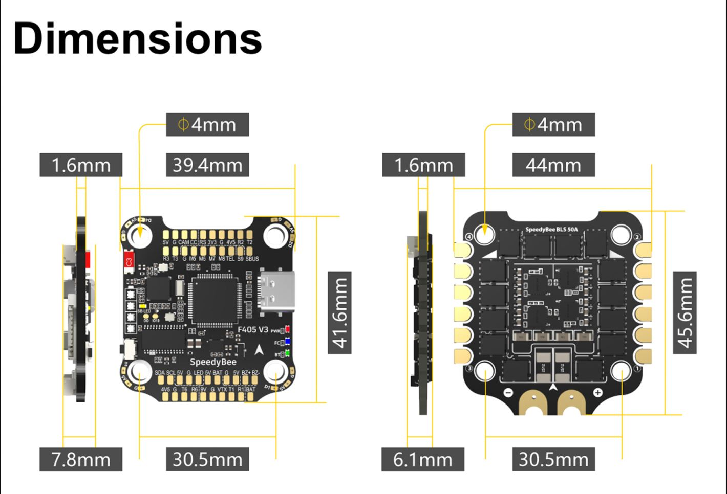

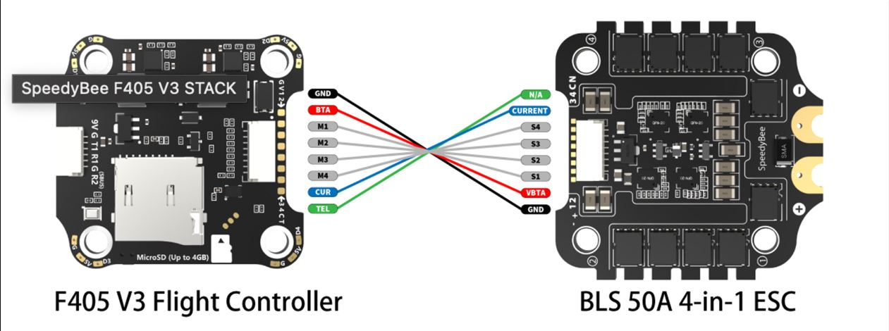

**Front:**

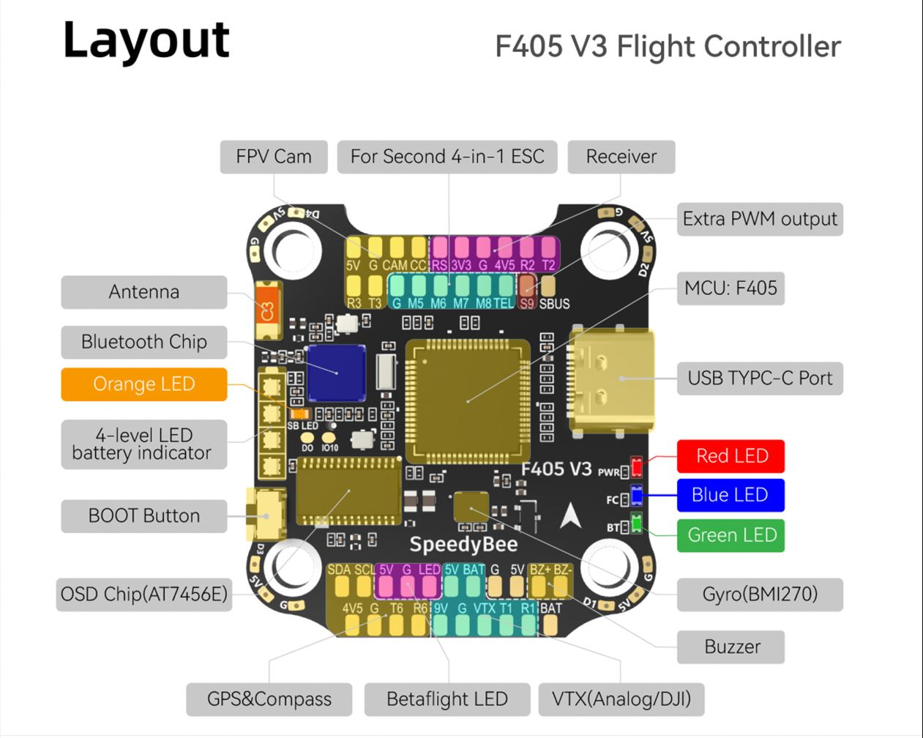

**Back:**

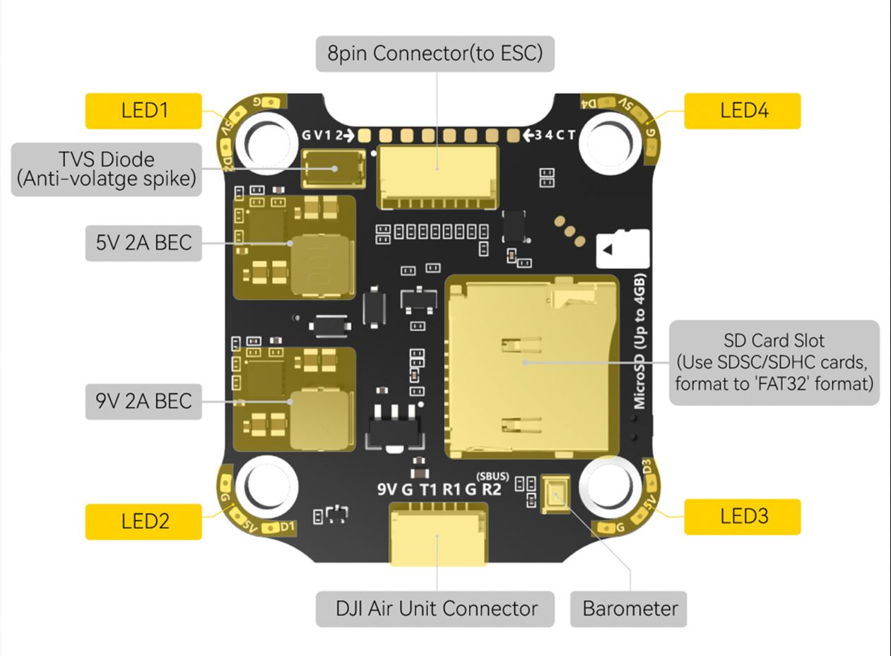

**ESD Schematic:**

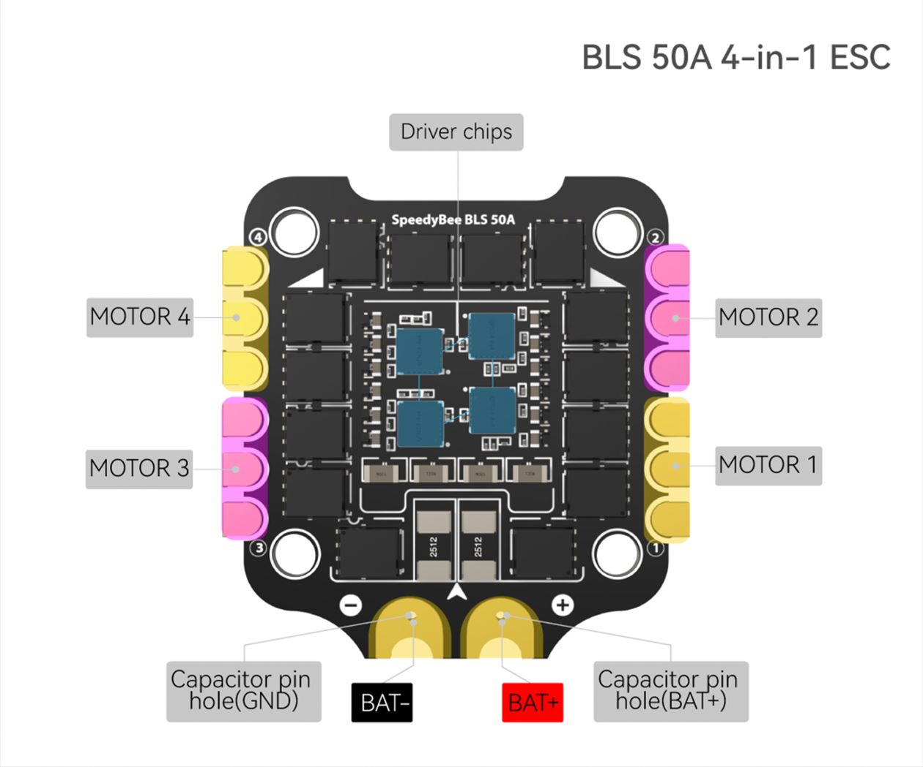

**Wiring Diagram:**

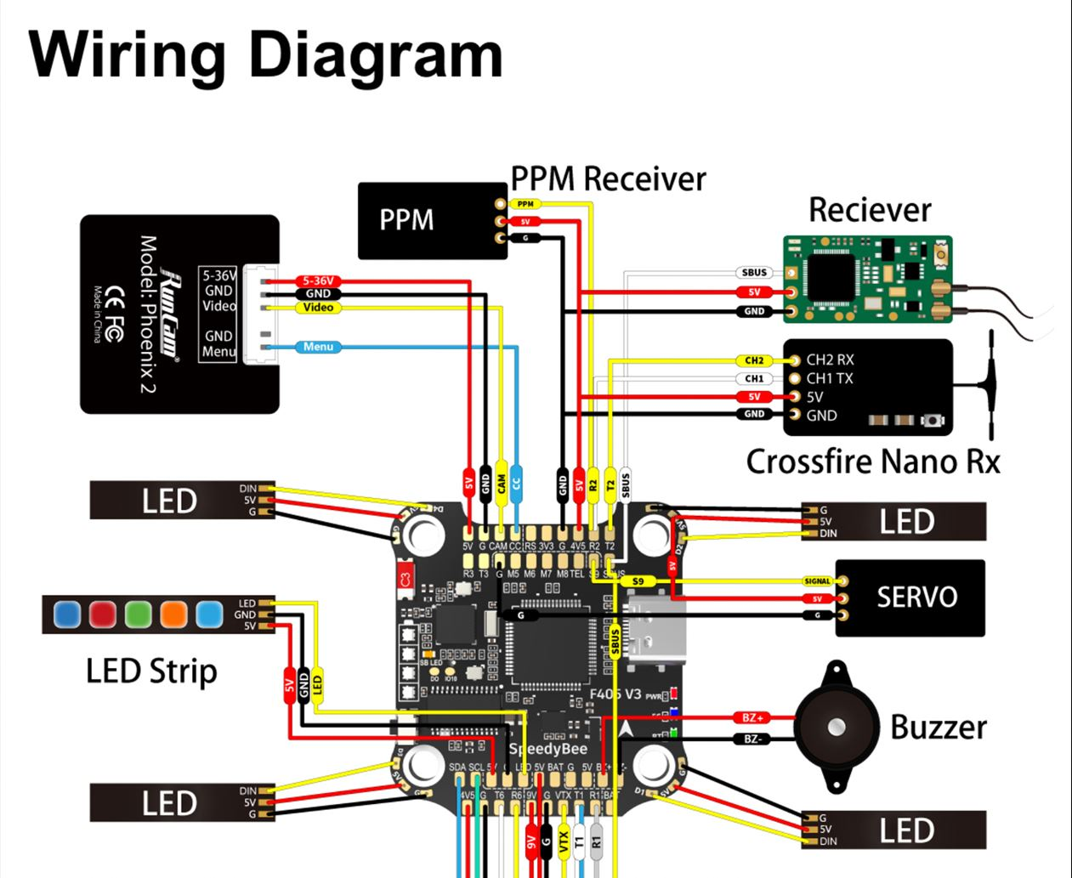

February 15th – Software to Control Drone:

I did some research on how to control the drone using a phone and apparently SpeedyBee offers their own app called “SpeedyBee”. However, this app is only used to configure the settings for the motors, sensors, gyroscope, accelerometer, GPS, etc. The best option I came across was the link John provided in one of our meetings called “QGroundControl”. It is software that fully enables flight control using MAVLink protocols. QGC is available on Windows, OS X, Linux, iOS, and Android devices.